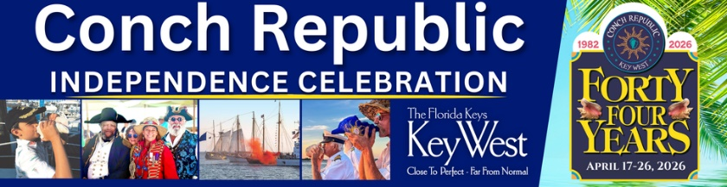
FOR IMMEDIATE RELEASE
APRIL 7, 2026

CONTACT: Julie McEnroe
PHONE: 305.923.0443
EMAIL: CRCelebration@gmail.com

Key West to celebrate the 44th anniversary of the founding of the Conch Republic April 17-26. Show your FUNdependence and party like it’s 1982!
Key West, Florida Keys & Conch Republic – Calling FUN lovers of all ages to gather in Key West for the 44th Anniversary Conch Republic Independence Celebration, April 17-26 for 10 days of 30+ unique, colorful, and “somewhat” historic events for all ages. Known as the Conch Republic’s 4th of July, Cinco de Mayo & Bastille Day rolled into one, for the Independence Day Ceremony, celebrating the 44th anniversary of the founding of the Conch Republic.
This whimsical, grassroots celebration features outdoor events held throughout Key West in waterfront parks, iconic bars, and unique island venues – with opportunities to party with the Conch Republic’s High Command, pirates, and island dignitaries. The celebration honors the island’s eccentric community and is a testament to the uniqueness and independent nature of the people who call the Florida Keys home.
Key West’s 44th annual Conch Republic Independence Celebration (CRIC 2026 for short) honors the founding of the Conch Republic, formed in 1982, in response to actions of the US government that put up a Federal Blockade at Florida City – removed several weeks later, due to the protests of the people who reside in the Keys.
Party with the Conch Republic Military Forces High Command, pirates and Conch-stituents – and raise monies for local charities. Show off your competitive spirit in silly races. Vie for best pirate costume and show off your musical skills with a Conch shell horn. Sail to Sand Key aboard a tall ship on the Wreckers Cup Race to Sand Key.
Shop for one-of-a-kind treasures at open air markets. Enjoy events held at waterfront parks, iconic bars, and historic venues – and don’t miss the Great Battle of the Conch Republic in Key West Harbor April 24, an “All in FUN” skirmish that pits United States Coast Guard vessels
-continued-
44th Annual Conch Republic Independence Celebration
Press Release, March 23, 2026
Page 2

against the fierce power of Conch Republic Military Forces. With battle ammo consisting of water cannons, Cuban bread, Conch fritters, and most importantly, humor. As First Sea Lord and Supreme Commander Emeritus, Admiral Finbar always said, “It’s war done right.”
Dedicated to bringing humor, warmth, respect, and peace, to a world in need of all four, the Celebration embraces our island’s philosophy ‘We are all One Human Family.’ Stop by the Official CRIC 2026 Welcome Center at Thompson Plaza at the Historic Seaport, foot of Elizabeth & Green, for celebration schedule brochures, event tickets, and ‘Official Conch Republic merchandise and citizen passports.
Key West’s 44th Anniversary Conch Republic Independence Celebration, presented by the Monroe County Tourist Development Council - District Advisory Council 1, City of Key West, Conch Republic Military Forces, and members of the Florida Keys business community, including Historic Tours of America, Key West Historic Seaport, and Schooner Wharf Bar & Galley.
# # #

