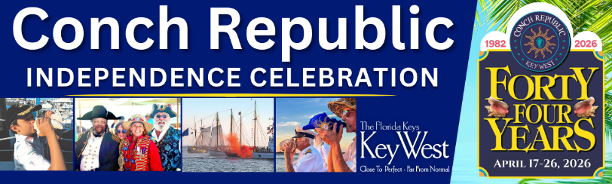

It’s time to declare your FUN-dependence and party like it’s NINETEEN EIGHTY-TWO!
Join us as we kick off our TWENTY TWENTY-SIX Conch Republic Independence Celebration, filled with TEN days of family friendly events for all ages.

There’ll be plenty of live music and great parties at historic venues, waterfront parks and iconic bars throughout Key West.

Visit CONCH REPUBLIC DOT COM for full schedule of events and tickets. That’s CONCH REPUBLIC DOT COM for info and tickets.

FORTY FOURTH ANNUAL Independence Celebration, APRIL SEVENTEEN TO TWENTY-SIX, brought to you by the Monroe County Tourist Development Council – DAC 1, Conch Republic Military Forces, and Florida Keys businesses.

# # #


