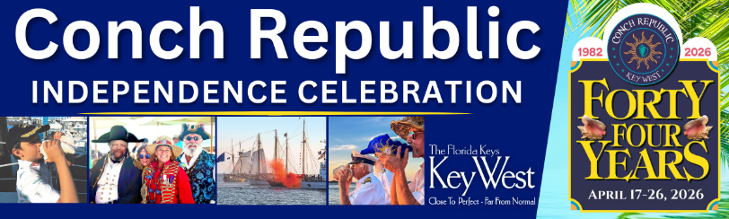
Conch-Tail Party, Dinner & Sunset Toast to ‘Long Live the Conch Republic’
April 21, at Ocean Key Resort & Spa’s Sunset Pier, ZERO Duval

Key West, Florida Keys and Conch Republic… Calling all Pirates, Partiers, and Conch-stituents to join the Conch Republic Military Forces and island dignitaries for their Conch-Tail Party , Dinner & Sunset Toast (live & virtual) to ‘Long Live the Conch Republic’ at Ocean Key Resort’s Sunset Pier on April 21.
The party promises to be filled with lots of Conch Revelry and carries on the tradition born from last year’s Crossing the Bar Ceremony for the Conch Republic’s Supreme Commander Emeritus, First Sea Lord Admiral Finbar. Festivities include the CRMF Presentation of the Colors and 21 Conch Shell Salute; and guests will enjoy a ringside seat to the breathtaking pageantry of the tall ships raising their sails as they sail off to the sunset – and cannon salutes as they return to the harbor.
Sip Conch-Tails and enjoy live music featuring Reggae Lou and special guest Sir CW Colt, Royal Minstrel of the Conch Republic, who will perform ‘One Human Family,’ chosen as the ‘Official Song’ of the City of Key West, and ‘The Peacefull Warrior’, his ode to his friend and kindred spirit, Capt. Finbar.
Dinner tickets are $60 / $50 if purchased before April 10, and include a scrumptious meal, coffee, tea or water, Key Lime Pie, and specialty Conch-Tails sponsored by Mutiny Island Vodka, Conch Republic Rum, and Smuggler’s Choice Key West Trading Company’s Smuggler’s Premier Bourbon, and Ocean Key Resort and Spa. Proceeds will benefit the Conch Republic Military’s Cuties in Action (CIA – Shhh!) and other their other branches, including the Aerospace Program, Air Force, Army, Green Ops, Marine Army, and Navy.

Conch-Tail Party & Toast dinner tickets include reserved seating, dinner with Key Lime pie – and Conch-Tail. To purchase tickets and more info on all celebration events, visit ConchRepublc.com.
The Conch Crawl is one of 30+ FUN-filled festivities held during the 44th Anniversary Conch Republic Independence Celebration, scheduled April 17 - 26, 2026, and is presented by the Monroe County Tourist Development Council DAC 1, Conch Republic Military Forces, and Florida Keys business community.
# # #

