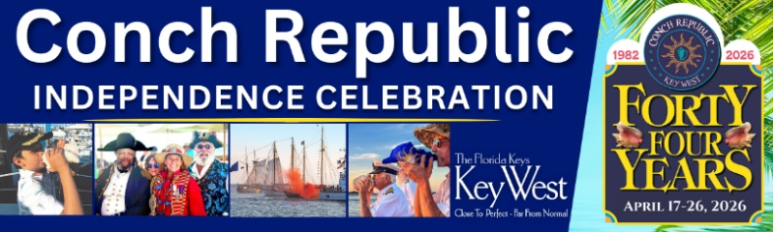
Join the 2026 Conch Crawl & Pub Stroll and enjoy libations at
nine iconic bars in Old Town Key West on April 18

Key West, Florida Keys and Conch Republic… Join the 2026 Conch Crawl and Pub Stroll, on April 18, hosted by the Conch Republic Military Forces and receive a commemorative Crawl Tee (while supply lasts) and enjoy libations at nine iconic bars. Enjoy time at 801 Bourbon Bar, Mangoes, Hank’s Hair of the Dog, Kaya Island Eats, Doc’s on Duval, Irish Kevin’s, Rick’s, and Salty Frog’s Bar & Grill – and bonus stops at Southernmost Pint Brewpub, and Bali Bar (for the Conch Republic Rum Launch Party from 3-7 PM.)

Crawl registration begins at 12:45PM at 801 Bourbon Bar, 801 Duval Street, strolls down Duval Street, ending at Salty Frog’s “After the Crawl Party, featuring live music, food and drink specials and giveaways, Conch Crawl tickets are $50 / $60 if purchased by April 10.

Sponsored by Mutiny Island Vodka, Key West Trading Company, Key West First Legal Rum, Cayo Hueso Brewing, and Papa’s Scooters, Conch Crawl proceeds benefit the Cuties in Action (CIA – Shhh!!) and the six branches of the Conch Republic Military Forces. To purchase Conch Crawl tickets and more information on all celebration events, visit ConchRepublc.com.


The Conch Crawl is one of 30+ FUN-filled festivities held during the 44th Anniversary Conch Republic Independence Celebration, scheduled April 17-26, 2026, and presented by the Monroe County Tourist Development Council DAC 1, Conch Republic Military Forces, and Florida Keys business community.
# # #

