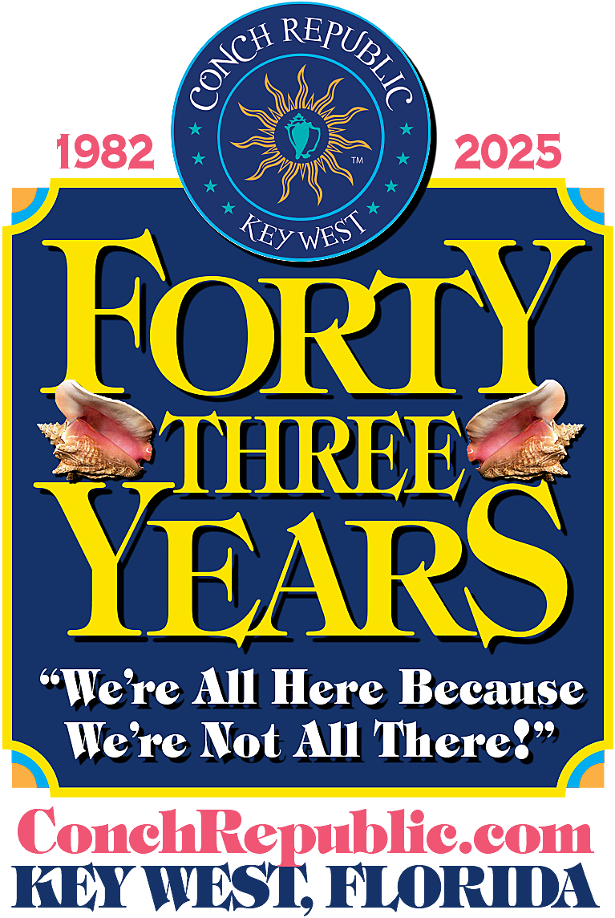
43rd INDEPENDENCE CELEBRATION
EVENT CALENDAR
APRIL 18-27, 2025

Event Tickets & Complete Schedule Online
at ConchRepublic.com

DAILY
10AM - 9:00 PM CRIC 2025 HQ & WELCOME CENTER at the Key West Historic Seaport, foot of Elizabeth & Greene. Stop by and get your Celebration Pocket Guide and to purchase Official Conch Republic Passports, T-shirts, Flags and Souvenirs.
SAIL ABOARD MAJESTIC HISTORIC SCHOONERS, including Danger Charter’s Danger’s Prize, Danger’s Pearl, and Sarah; Sunset Sail Key West’s When & If, and the Jolly II Rover, Spirit of Independence and America 2.0, and Luxury Catamaran Argo Navis. *Get Tickets online!
DAY & SUNSET SAILS, SNORKEL TRIPS & ALL-DAY ADVENTURES AT SEA & IN THE WATER aboard Danger Charters and Sunset Sail Key West fleet of shallow draft vessels ideal for snorkeling, kayaking, and playing in the water.
SPECIAL EVENTS AT UNIQUE & HISTORIC VENUES
FRIDAY, APRIL 18TH
8:00 AM - 9:00 AM: 10th Annual CONCHY BEACH CLEANUP AT HIGGS BEACH with KW Ploggers, Keep Key West Beautiful, CR Green Ops, and CR Air Patrol. Meet at KW Bocce Court parking lot, 1801 White Street, across from the Atlantic Ocean. FREE.
10:00 - 11:30AM LEGENDS OF KEY WEST & The CONCH REPUBLIC Old Town Walking Tour with Island Audio Tours Magic Frank and Josh. Learn the real stories behind Captain Tony, Mel Fisher and Captain Finbar, three of the saltiest characters who once called Key West home. COST: $49. Advanced reservations required. For more info, visit: IslandAudioTours.com *Get Tickets online!
4:30-5:00 PM OPENING CEREMONY & RAISING OF THE COLORS at Mallory Square, 400 Wall St. Lighthearted Ceremony with CR Military & Island Dignitaries at Mallory Square celebrates the official start of our 43rd Independence Celebration. Festivities include the CR Pledge of Allegiance & Battle Hymn, Conch Shell-Horn Salute. Live music with CR Royal Minstrel, Sir CW Colt. FREE
7:00 PM - SCHOONER WHARF KICK-OFF PARTY & CONCH SHELL BLOWING CONTEST hosted by Schooner Wharf Bar & Galley, CRIC 2025 Party HQs, KW Historic Seaport, 202 William St. Party with Pirates & Island Dignitaries and Dance Under the Stars and learn the ‘real history’ behind our Secession! Visit SchoonerWharf.com for more info. FREE (Cash Bar)
SATURDAY, APRIL 19TH
8AM 26TH Annual EARTHDAY 5K benefits CR Marine Army, Truman Waterfront Park. Visit ConchRepublicMarineArmy.com to learn more about their Saturday Clean Ups & Charters.
8: 00AM - 1:00 PM 4th Annual STOCK ISLAND EARTHDAY COMMUNITY CLEAN UP at Bernstein Park, 6751 5th St. Clean-up runs all morning – so stop by when you can. Vests, pokers, and buckets provided. Adults must accompany children for cleanup. Sponsored by I Love Stock Island and Stock Island Association. FREE
10:00AM - 6:00 PM 41st Annual CONCH REPUBLIC ART & CRAFT DUVAL STREET FAIR between Eaton & Greene. Purchase one-of-a-kind artworks from local artists you will treasure for a lifetime. For more info, visit: SunsetCelebration.org. FREE

1:30 PM CONCH CRAWL PUB STROLL includes libations at EIGHT historic saloons (including 801 Bourbon Bar, Kaya Island Eats, Hanks Hair of the Dog, Willie T’s, Rick’s Downstairs, Irish Kevin’s, Mango’s and Salty Frog’s). Sponsored by KW Trading Co., KW First Legal Rum Distillery, Hard Truth Distilling, Mutiny Island Vodka, and Liquor Split.
Crawl tickets include EIGHT drinks (one at each stop.) After Party and…a complimentary Collectible Conch Crawl T-shirt (while supply lasts.) For more info email: ConchPubCrawl@gmail.com.
EARLY BIRD Advanced Tickets $45. Rain or Shine. *Get Tickets online!
Proceeds benefit TREE Institute, CR CIA (Shhhh! Cuties in Action) and Flagship WOLF Preservation Society.

2:00 PM - 6:00 PM 43rd Annual CR DRAG RACES ON DUVAL at Bourbon Street Pub, 724 Duval St. Don your high heels & best frock and enter… or cheer on the hottest drag queens as they go heel to heel for a series of races & obstacle courses. For more info, call: 305 747 0343. **FREE SIGN UP AT EVENT ONLY.
SUNDAY, APRIL 20th - EASTER!
10:00 AM - 2:00 PM KW ARSTISAN MARKET-EASTER EDITION at Higgs Beach, 1801 White St. Shop local artists & specialty foods. Enjoy live music and Easter Egg Hunt. For more info, visit Facebook.com/KeyWestArtisanMarket FREE
HIGH NOON COW KEY CHANNEL BRIDGE O-k – “BUNNIES & BOVINES” Meet at the KW side of the bridge. Pre-Race Registration Party starts at 10AM. Open to all ages. Awards Ceremony 1:30 PM - 3:30 PM at KW Power Squadron, 5205 College Road. Proceeds benefit MCSO Animal Farm & Petting Zoo. Learn more about the race and Volunteer opportunities at phantompress.com/cow or email Reverend Gweko at SouthernmostMedia@gmail.com FREE
5:00 PM – 7:30 PM JAZZ IN THE GARDENS, The Gardens Hotel, 526 Angela St. The d'vine Wine Gallery, set amongst an enchanting tropical garden, is the perfect place to enjoy a glass of wine while listening to great live music with world-renowned jazz artist Terri White. For more info: GardensHotel.com. FREE (Cash Bar)

MONDAY, APR 21st
5:00 PM - 8:00 PM CONCH REPUBLIC MUSICAL MILITARY MUSTER MONDAY & CONCH-TAIL PARTY Kaya Island Eats, 610 Duval St. Enjoy delicious C-rations and Truth Serum – if you dare! For more info: email: cutiesInaction@gmail.com. *Get Tickets online!
Sponsored by Key West First Legal Rum Distillery, Eagle Brands – Budweiser, KW Trading Co, Mutiny Island Vodka, Hard Truth Distilling & Liquor Split. Info: email cutiesinaction@gmail.com.
8:30 PM – 9:00PM MANDATORY CAPTAINS’ MEETING FOR CR NAVAL PARADES at Schooner Wharf Bar, CRIC 2025 Party HQs, Historic Seaport, 202 William St. Show your Conch Republic Patriotism and enter your vessel in our CR Naval Parades on April 23 and April 25. FREE (Cash Bar) Register your boat at ConchRepublic.com.
TUESDAY APRIL 22nd (EARTH DAY!)
6:00 PM - 10:00 PM HOT HAVANA NIGHT DANCE PARTY WITH CARIBE OF KW at Kaya Island Eats, 618 Duval St. Salsa the night away and enjoy RUM cocktails. Bid on authentic Cuban Treasures. Win a trip to Cuba! Enjoy Cuban Cuisine and cigars under the stars.
Sponsored by The Backyard Bar at Kaya and Rent KW Vacations. Proceeds benefit TREE Institute Int’l.
Early bird tickets start at $20. *Get Tickets online!
WEDNESDAY, APRIL 23rd
1:00 PM-2:30 PM “OLD MAN & THE SEA – RETURN TO CUBA” DIRECTOR’S CUT by Matt Dean Films at Tropic Cinema, 416 Eaton St. Filmed on location in Key West, aboard WOLF in the Florida Staits and in Cuba, Matt Dean’s documentary won the 2018 KW Film Festival’s ‘Best Florida Feature Award’ and follows Capt. Finbar on his first visit back to Cuba in 50 years. For more info, email Info@FlagshipWOLF.org Admission FREE. Donations to Flagship WOLF Preservation Society welcome.
4:00-4:30 PM 43rd Annual INDEPENDENCE DAY CEREMONY at Mallory Square, honors the founding of our Tiny Island Nation. Join CR Prime Minister Emeritus and former Key West Mayor, Dennis Wardlow, CR Speaker of the House Paul Menta, CR Secy of State CMDR James Gilleran and others for the CR Pledge of Allegiance. FREE
5:00 PM - 9:00 PM CAPTAIN FINBAR’S CROSSING THE BAR CEREMONY & FAREWELL SALUTE & TOAST TO LONG LIVE THE CONCH REPUBLIC at The Sunset Pier, Ocean Key Resort & Spa, Zero Duval St. Join us to salute Finbar’s 43 years of service to the CR and dedication to the KW maritime community. Enjoy live music, silent auction, and 21 Conch Shell Salute.
Dinner tickets are $45 and include seating for Ceremony at 5:30 PM & Toast at 7:30 PM. Advanced reservations required. For more info, email JulieMcEnroe@hotmail.com*Get Tickets online!
7:30-8:00 PM WORLD’S LARGEST VIRTUAL & LIVE TOAST at The Sunset Pier, Ocean Key Resort & Spa, Zero Duval St. Join CR Speaker of the House and RUM Administrator Paul Menta and other island dignitaries for a Toast to ‘Long Live the Conch Republic.’ Come early and celebrate First Sea Lord and Supreme Commander Emeritus ADM Finbar’s 43 years of service to the Conch Republic. FREE (Cash Bar)
Want to participate in the Toast and can’t attend? Sign up to LIVESTREAM the Toast & Rum Salute from wherever you are – at home, your favorite bar, restaurant or on the beach or on the water. Help us break the WORLD’s RECORD for the Largest Livestream Virtual Toast!
Proceeds benefit Flagship WOLF Restoration efforts so she can continue to offer Youth Sail Training and Humanitarian Missions of Mercy. For more info, email Info@FlagshipWOLF.com.
COST: $10. *GET SIGN UP LINK online!
THURSDAY, APRIL 24th
1:00-2:30PM “CUBA REFRAMED – THE POWER OF CONNECTION” presented by PeaceVision & Dreamtime Entertainment, at Tropic Cinema, 416 Eaton St. Filmed on location in Key West, aboard WOLF in the Florida Staits and in Cuba, follows WOLF crew on their 2019 trip to Cuba and provides insight into and share the perspective of the people who inhabit the eighth largest island nation in the world today.
Proceeds benefit Flagship WOLF Restoration efforts so she can once again offer Youth Sail Training and Humanitarian Missions of Mercy. For more info, email Info@FlagshipWOLF.com. CUBA REFRAMED PBS Sponsorships available. FREE
2:00 PM-7:00 PM TRUMAN WATERFRONT FARMERS MARKET – CONCH REPUBLIC EDITION at Truman Waterfront Park, foot of Southard St. KW’s Farmer’s Market offers fresh produce, specialty foods, and unique handmade arts & crafts. Info: visit: Facebook.com/KWFarmersMarket FREE
5:30 PM – 7:00 PM PARARADE PRE-PARTY at Mansion by the Sea’s Seaside Café, 1400 Duval St. Join us to celebrate 43 Years of FUN-Dependence, and mingle with Admirals, Pirates and Parade Participants. Enjoy live music and celebratory libations with a spectacular ocean view. Sponsored by The Mansion on the Sea and Seaside Café. For more info, visit: ConchRepublic.com. FREE (Cash Bar)
8:00 PM - 9:00 PM 40TH Annual WORLD’S LOOOOONGEST PARADE on Duval – From the Atlantic Ocean to the Gulf of Mexico. This world-famous, quirky, and colorful parade celebrates Conch Republic Independence. Come early and meet parade participants and their unique & quirky modes of transport. FREE. REGISTER YOUR float, marching unit, or vehicle and join the Parade! Parade Entry Forms are available online.
9:00 PM SCHOONER WHARF PARADE AFTER-PARTY at Schooner Wharf Bar, KW Historic Seaport, 202 William St. Dance to great live music under the stars, mingle with Conch Republic VIPS, CR Military Brass, Pirates and Patriots. Parade prizes for Best “Conch-cept,” Most Original & Most Creative parade entries. For info, visit SchoonerWharf.com. FREE (Cash Bar)

FRIDAY, APRIL 25TH
8:00 AM – 9:00 AM: MALLORY SQUARE CLEAN UP, 400 Wall Street. Join members of KW Ploggers, Keep Key West Beautiful, CR Green Ops, and CR Aerospace Program. FREE
10:00 - 11:30AM LEGENDS OF KEY WEST & The CONCH REPUBLIC Old Town Walking Tour with Island Audio Tours Magic Frank and Josh. Learn the real stories behind Captain Tony, Mel Fisher and Captain Finbar, three of the saltiest characters who once called Key West home. COST: $49. Advanced reservations required. For more info, visit: IslandAudioTours.com *Get Tickets online!
6:30PM 42ND Annual CR GREAT SEA BATTLE REENACTMENT LAND FORCES at Mallory Square. Join GEN Scarlett, Supreme Commander of the CR Military, and members of the CR Army and Navy as they prepare to fend off the enemy from shore. FREE (Cash Bar)
7:00 PM 42ND Annual CR INDEPENDENCE NAVAL PARADE in Key West Harbor, alongside Mallory Square. Join the parade! Register your vessel and deck it out with colorful Conch Republic flags and celebrate 43 Years of FUN-Dependence at sea! Best viewing at Mallory Square Sunset Celebration, Opal Resort & Marina, and Ocean Key Resort & Spa Sunset Pier. FREE (Cash Bar)
**REGISTER YOUR VESSEL IN THE CR INDEPENDENCE BOAT PARADE! Boat Parade Entry SIGN UP online. Enter your vessel in the parade online, at ConchRepublic.com.
7:00 PM 42ND Annual REENACTMENT OF THE GREAT SEA BATTLE OF THE CONCH REPUBLIC. In, alongside and above Key West Harbor, the Battle is a highlight of our celebration. This large scale, hilarious harbor battle pits the CR’s Military Forces (Air Force, Army, and Navy) and CR Privateers of all shapes and sizes against their valiant foe, none-other than the United States Coast Guard.
The good-natured foes represent the USCG Cutter Diligence, attacked April 23, 1982, by the Schooner Western Union, the first Flagship of the Conch Republic. The best free viewing is at Mallory Square, Opal Resort & Marina, Ocean Key Resort & Spa Sunset Pier. FREE (Cash Bar)
8:00 PM 42ND Annual SCHOONER WHARF “SURRENDER CEREMONY & VICTORY PARTY”, at CRIC 2025 Party HQs, 202 William St, Historic Seaport, After the Great Battle, join the CR Military & ‘Coasties’ for a Tongue-in-Cheek Surrender Ceremony of the US Coast Guard to the CR Armed Forces – “A Farce to be Reckoned With!” For more info, visit: SchoonerWharf.com. FREE (Cash Bar)
SATURDAY, APRIL 26TH
1:00 PM - 6:00 PM Julie Hansen Memorial BED RACES ON DUVAL, 801 Duval St. (between Olivia & Southard.) Said to be “The most fun you can have with your clothes on,” this zany race takes place on Duval between Olivia and Southard. Put together your own team and decorate a bed to compete for prizes in this hilarious race.
Come early to meet the teams and stroll the crazy, colorful beds competing for the ‘BLUE RIBBON.’ Proceeds benefit Key West’s Sister Season, “Locals Helping Locals.” Registration is 1-3 PM, Race at 3 PM, Awards Ceremony at 6 PM. For more info and to REGISTER YOUR , visit: SisterSeason.org
7-:00 PM – 10:00 PM 2nd Annual Ricky Jackson‘s BRAWL ON DUVAL (Greene & Duval.) Exhibition Fighting Event, Greene & Duval. Enjoy Boxing, Kickboxing, Wrestling and Jiu Jistu - and support the KW PAL (Police Athletic League.) VIP Tickets for Ringside & Balcony Seating are available. For tickets and more info, visit: BrawlOnDuval.com
7:00-8:00 PM SCHOONER WHARF “WRECKERS CUP RACE” 40TH ANNUAL CAPTAINS’ MEETING at Schooner Wharf Bar, “Official CRIC 2025 Party Headquarters,” KW Historic Seaport, 202 William St. Mandatory meeting for April 28 race in the Sail Loft. Sign up, or for info: SchoonerWharf.com. FREE (Cash Bar).
7:00 PM 40TH SCHOONER WHARF PIRATE BALL & COSTUME COMPETITION at Schooner Wharf Bar, KW Historic Seaport, 202 William St. Yo Ho Ho! And a Bottle of Rum – It’s a Pirate’s Life for You! Witness swashbuckling sword play, enjoy sea shanties. Live Music, food & drink, For more info, SchoonerWharf.com. FREE (Cash Bar)

SUNDAY, APRIL 27TH
10:00 AM – 2:00 PM KEY WEST ARTISAN MARKET – CONCH REPUBLIC EDITION at Higgs Beach, 1801 White St. Where the locals meet! Shop local artists, specialty food vendors, and enjoy live music by the Shanty Hounds. For more info, visit Facebook.com/KeyWestArtisanMarket FREE
1:00 PM - 4:00 PM 40TH Annual SCHOONER WHARF “WRECKERS CUP RACE” 40th Annual Race to Sand Key Lighthouse with the Schooner Wharf Wreckers Fleet. Or enter your own vessel in the final race of the 2025 season! Enjoy a delightful afternoon at sea on the waters off Key West aboard a majestic schooner, sloop, or multi-hull. This ‘all-in-fun race series’ recalls the tradition of the wreckers during the 1800s. Best viewing. for Race Start is at Mallory Square. For more info, visit: SchoonerWharf.com.
5:00 PM - 7 :30PM JAZZ IN THE GARDENS, The Gardens Hotel, 526 Angela St. The d'vine Wine Gallery, set amongst an enchanting tropical garden, is the perfect place to enjoy a glass of wine while listening to great live music with world-renowned jazz artist Scott Marischen. For more info, visit: GardensHotel.com. FREE (Cash Bar).
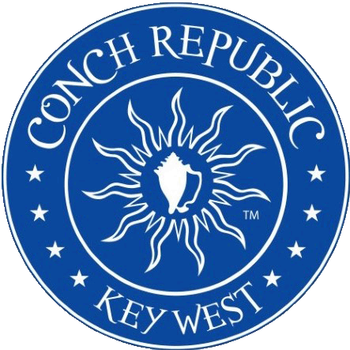
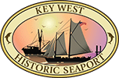
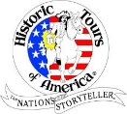
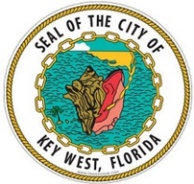
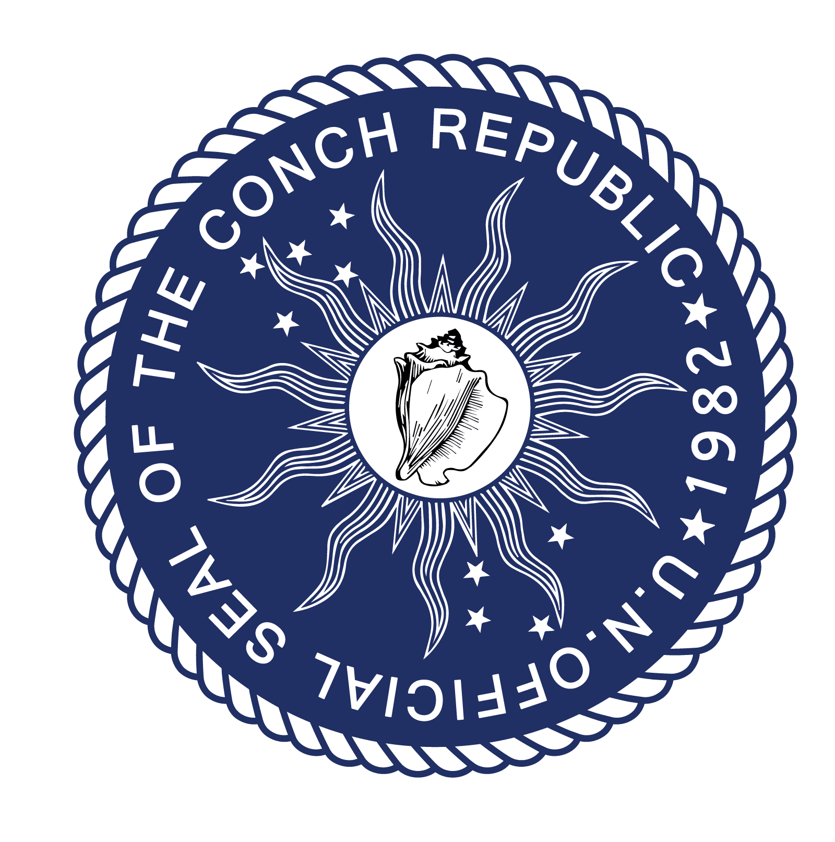
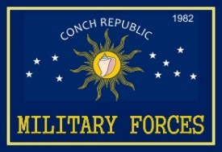
7:00 PM 40TH Annual SCHOONER WHARF WRECKERS CUP RACE AWARDS PARTY, KW Historic Seaport, 202 William St. View video of the race while enjoying a BBQ dinner and live music with race participants. For more info, visit: SchoonerWharf.com. FREE (Cash Bar)
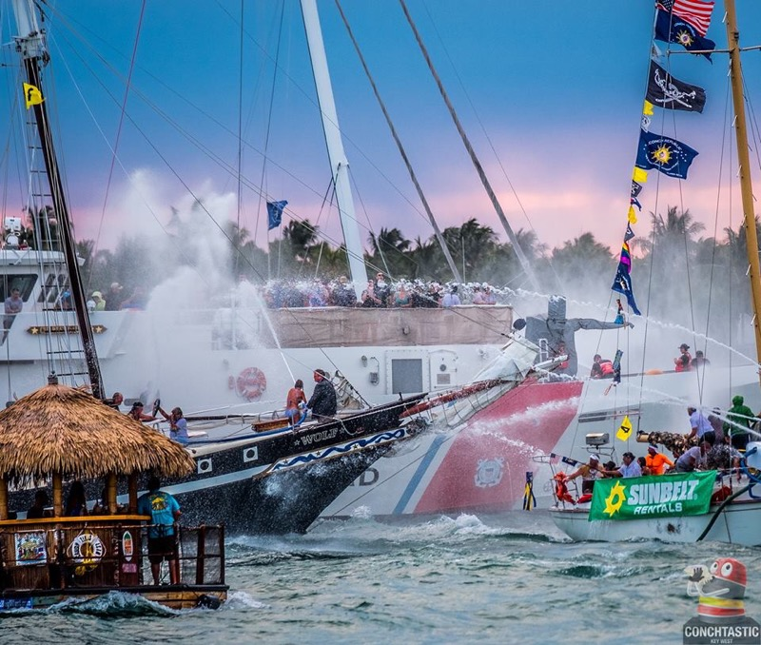

Long Live the Conch Republic!
We Seceded Where Others Failed
CONCHREPUBLIC.com

