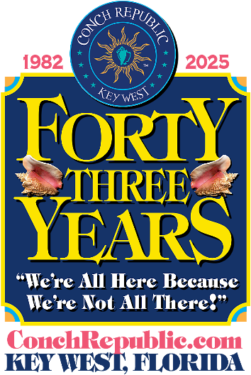
FOR IMMEDIATE RELASE
April 5, 2025

CONTACT: Julie McEnroe
PHONE: 305.923.0443
EMAIL: Info@ConchRepublic.com

Key West to celebrate the 43rd anniversary of its secession with
10 Days of 20+ FUN-filled festivities for all ages! APRIL 18-27, 2025
We Seceded Where Others Failed!

Key West, Florida Keys & Conch Republic – Calling FUN lovers of all ages to gather in Key West for the 43rd Anniversary of the Conch Republic Independence Celebration, April 18-27, 2025. Party with the Conch Republic High Command, pirates, and island dignitaries, and enjoy 20+ unique, colorful, and ‘somewhat’ historical events, packed into 10 days of FUN-Dependence.

The Celebration honors the island’s eccentric community and is a testament to the uniqueness and independent nature of the people who call the Florida Keys home.
This whimsical, grassroots Celebration features outdoor events, held throughout Key West in waterfront parks, storied saloons, and unique island venues,

Key West’s 43rd Anniversary Conch Republic Independence Celebration (CRIC 2025 for short) honors the founding of the Conch Republic. Formed in 1982 in response to actions of the US government who put up a Federal Blockade at Florida City, the blockade was taken down several weeks later due to the protests of the people who reside in the Keys.

Cheer on or compete in the Earth Day 5-K Run (April 19) and silly and hilarious competitions, including the Great Drag Races (April 19), Cow Key Channel Bridge 0-K (April 20), Julie Hansen Memoria Bed Races (April 26) and enjoy an afternoon racing to Sand Key Lighthouse during the 40th Annual Schooner Wharf Wrecker’s Cup Race (April 27.)
- continued -
43rd Annual Conch Republic Independence Celebration
Press Release, April 5, 2025
Page 2

The Celebration also offers plenty of opportunities to party with members of the CR High Command and island dignitaries. Show your Conch Republic pride at the Opening Ceremony & Raising of the Colors at Mallory Square (April 18) and bend elbows with Admirals, Generals and Ambassadors at the CR Military Muster at Kaya, a benefit for the Wesley House CR Foster Childrens Fund (April 20.)

On April 23 – the Conch Republic’s 4th of July, Cinco de Mayo & Bastille Day – all rolled into one,
Festivities include a Flag Ceremony at Mallory Square with founding CR Prime Minister and former Key West Mayor, Dennis Wardlow and Speaker of the House and Administrator of Rum, Paul Menta. Festivities continue at The Sunset Pier at the Ocean Key Resort and Spa and include Captain Finbar’s Crossing the Bar Ceremony & Farewell Salute, with 21 Conch shell horn salute and CRMF Color Guard, and the first annual World’s Largest Virtual Toast to Long Live the Conch Republic.

Learn the history and storied pasts of some of the Conch Republic’s saltiest characters on the Legends of Key West Old Town Walking Tours (April 18 & 25.) Sip and stroll your way down Duval with stops at eight saloons in Old Town during the annual Conch Crawl (April 19.)

Honor Mother Earth and Father Ocean in the Conch Republic and join the Key West Ploggers, Keep Key West Beautiful, the CR Green Ops and Plogging the Keys for their annual Conchy
Beach Clean Up Higgs Beach (April 18), I LOVE Stock Island Earth Day Clean Up at Bernstein Park (April 19) and Plogging the Keys Mallory Square Clean Up on April 25.

Find one-of-a-kind treasures and artworks at the 41st Annual Arts & Crafts Duval Street Fair (April 19.) Celebrate Easter at the Key West Artisans Market – Easter Edition at Higgs Beach Indigenous
-continued-
43rd Annual Conch Republic Independence Celebration
Press Release, April 2, 2025
Page 3
Park (April 20) and Conch Republic Edition (April 27) to shop local artists and specialty foods. The Conch Republic Truman Waterfront Market (April 24) is the place for local produce and arts and crafts
Everyone loves a parade and the Celebration’s World’s Loooongest Parade on Duval (April 24) and the Conch Republic Naval Independence Parade in Key West Harbor (April 25) are not to be missed. Join the street parade and decorate your car, bike or golf cart, or enter your own float or marching unit. Captains are invited to enter their vessels for the 42nd Annual CR Naval Independence Boat Parade which precedes the Great Battle (April 25) in Key West Harbor, alongside Mallory Square.

The signature event of the Celebration is the 42nd Reenactment of The Great Battle of the Conch Republic, which is an “All in FUN” skirmish that pits a United States Coast Guard Cutter against the mighty fierce power of CR Military Forces. Afterwards, join the combatants for the Schooner Wharf Great Sea Battle Surrender Ceremony and Victory Party (April 25) for this ‘tongue in cheek’ ceremony between the United States Coast Guard and Conch Republic Military Forces.

Like the first Great Sea Battle of the Conch Republic which was fought aboard the schooner Western Union in 1982, the ammo of choice includes water cannons, Cuban bread, Conch fritters, and most importantly, humor. As First Sea Lord and Supreme Commander Emeritus, ADM Finbar
always said, “War done right.” Best FREE viewing for the CR Naval Independence Parade and Reenactment of the Great Sea Battle is at Mallory Square.

Celebration participants also enjoy FUN Fundraisers for local charities, including: the Military Muster at Kaya raises funds for Wesley House CR Foster Care Kids Program, and he fun

- continued -
43rd Annual Conch Republic Independence Celebration
Press Release, April 5, 2025
Page 4

continues at Kaya as the Conch Republic meets Cuba on the dance floor at the Hot Havana Night Dance Party with Caribe KW (April 22) a benefit for the TREE Institute International. The Brawl on
Duval Amateur Boxing Match returns to the corner of Greene (April 26) and supports the Key West Police Athletic League.

While visiting Key West, take to the sea aboard a majestic Tall Ship or luxury catamaran, or spend time on the water, kayaking, snorkeling, or relaxing at the beach. So many FUN things to do! During the Celebration, stop by our ‘Official CRIC 2025 HQs’ at Thompson Plaza, foot of Elizabeth & Green, at the Historic Seaport, for your complimentary Program Guide, with complete schedule of festivities, to purchase event tickets, and stock up on ‘Official Conch Republic’ merchandise.

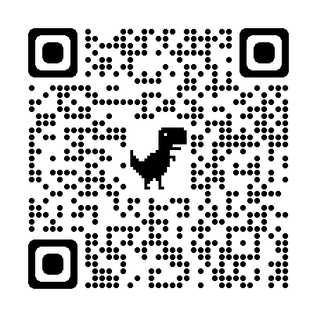
Dedicated to bringing Humor, Warmth, Respect and Peace, to a world greatly in need of all four, the Conch Republic Independence Celebration embraces our island’s philosophy ‘We are all One Human Family.’ Key West’s 43rd Annual Conch Republic Independence Celebration is brought to you through the generous support of the Conch Republic Military Forces, Key West Historic Seaport and many members of the Florida Keys business community. For a full schedule of festivities, event tickets, and all things Conch Republic, visit: ConchRepublic.com.

43RD ANNIVERSARY
CONCH REPUBLIC INDEPENDENCE CELEBRATION
APRIL 18-27, 2025
10 Days of FUN-Filled Festivities for All Ages on Land & Sea!

ConchRepublic.com


  
