Conch Republic Independence Celebration Announces Winners
of the First Annual Student Celebration T-shirt Art Contest

Key West, Florida Keys and Conch Republic… Organizers of the 42nd Anniversary Conch Republic Celebration are excited to announce the winners of their first annual Student T-shirt Artwork Contest.
Students at Key West’s Horace O’Bryant Middle School, their artwork is featured on 2024 Celebration T-shirts, Emely Olmos de Loen’s Conch shell on the front, and Ashly Parado’s artwork on the back.

They, along with other student participants will be recognized at the Independence DAY Ceremony at the Truman Waterfront, April 23 at 5:30PM. 42nd Birthday festivities run 5-8pm and are FREE to the public, and include live music with Sir CW Colt and Dani Hoy, Rich McKay and other local favorites.

Open to the public, Ceremony & Muster tickets are available online, and include reserved Ceremony seating, C-rations from Jersey Mike’s, and refreshments hosted by the Conch Republic’s CIA – Shhh! Cuties in Action.

The first annual CR Celebration Student T-shirt Artwork contest, open to all Monroe County students, and students under 21 enrolled in the College of the Florida Keys, was the idea of CFK’s Kelly Conklin-Penwell, Director of the CFK Business Program. Suggesting the idea, Celebration organizers took it from there and shirts can be pre-ordered online at ConchRepublic.com

Scheduled April 19-28, Key West’s 42nd Conch Republic Independence Celebration features over twenty fun events for all ages, and is brought to you in part by the Monroe County Tourist Development Council DAC 1, and Keys business community.
# # #

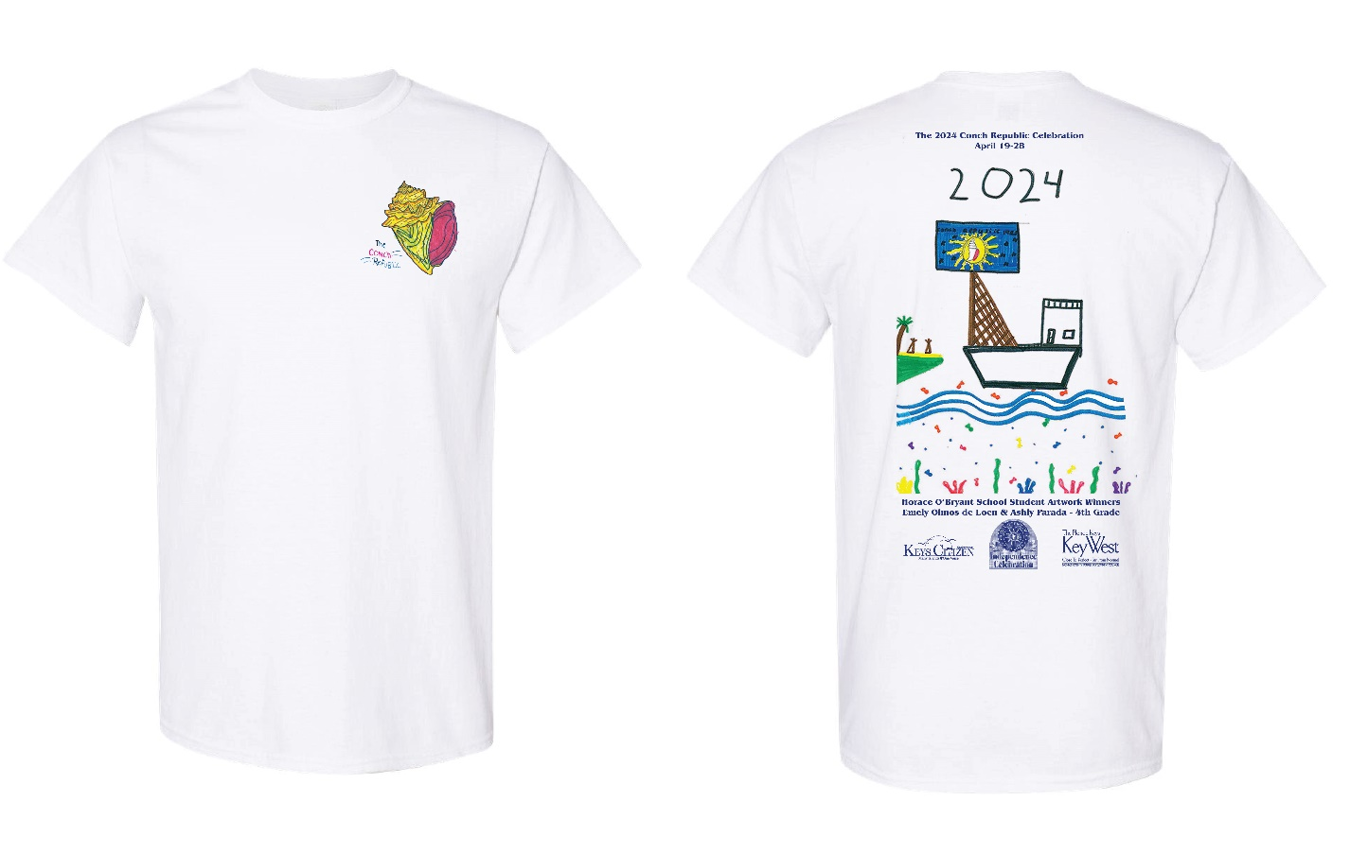

42nd Anniversary Conch Republic Independence Celebration
Student T-shirt Artwork Competition Winning Artwork

PRE-ORDER T-SHIRTS ONLINE AT
ConchRepublic.com

YOUTH SIZES $20
Small, Medium, Large and X-large

ADULT SIZES $25
Small, Medium, Large, X-large, XX-large, and XXX-large

