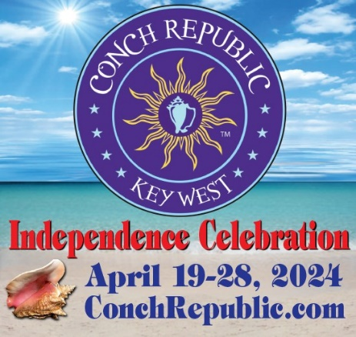
FOR IMMEDIATE RELASE
March 18, 2024

CONTACT: Julie McEnroe
PHONE: 305.923.0443
EMAIL: Info@ConchRepublic.com

Key West to celebrate 42nd anniversary of its secession with
10 Days of 20+ FUN-filled festivities for all ages! APRIL 19-28, 2024
We Seceded Where Others Failed!

Key West, Florida Keys & Conch Republic – Calling FUN lovers of all ages to gather in Key West for the 42nd Anniversary of the Conch Republic Independence Celebration, April 19-29. Party with the Conch Republic High Command, pirates, and island dignitaries, and enjoy 20+ unique, colorful, and ‘somewhat’ historical events, packed into 10 days of FUN-Dependence.

The Celebration honors the island’s eccentric community and is a testament to the uniqueness and independent nature of the people who call the Florida Keys home.
This whimsical, grassroots Celebration features outdoor events, held throughout Key West in waterfront parks, storied saloons, and unique island venues,

Key West’s 42nd annual Conch Republic Independence Celebration (CRIC 2024 for short) honors the founding of the Conch Republic, formed in 1982, in response to actions of the US government who put up a Federal Blockade at Florida City. The blockade was taken down several weeks later due to the protests of the people who reside in the Keys.

- continued -
42nd Annual Conch Republic Independence Celebration
Press Release, March 18, 2024
Page 2

Cheer on or compete in silly and hilarious competitions, including Great Drag Races, April 20, the Blue-Ribbon Bed Races, April 27, and the Wrecker’s Cup Race Series to Sand Key Lighthouse, April 28.

Everyone loves a parade and the Celebration’s World’s Loooongest Parade on Duval, April 25, and CR Naval Independence Parade in Key West Harbor are not to be missed.

The Celebration also offers plenty of opportunities to party with Pirates and members of the CR High Command, including the Independence Day Ceremony & Military Muster at Truman Waterfront Pier, April 23. Sip and stroll your way down Duval with stops at saloons in Old Town, including Hank’s Hair of the Dog, during the annual Conch Crawl (Apr 27) and ‘Party like a Rock Star’ at the Gates Hotel Pool Party (April 28.)

Find one-of-a-kind treasures and artworks at the 40th Annual Arts & Crafts Duval Street Fair (April 20.) Shop specialty foods, local produce and arts and crafts at the Conch Republic Truman Waterfront Market, April 25, and Key West Artisans Market at Higgs Beach Indigenous Park (April 28.)

Celebrate Mother Earth and Father Ocean in the Conch Republic and join the Key West Ploggers and Keep Key West Beautiful for their annual Conchy Beach Clean Up, April 19.
- continued -
42nd Annual Conch Republic Independence Celebration
Press Release, March 18, 2024

Join the 3rd Annual I Love Stock Island Clean Up and visit Mote Marine’s environmentalists and scientists at the 14th annual Ocean Fest at Truman Waterfront Park, both on April 20.
Show your Conch Republic pride at the Opening Ceremony & Raising of the Colors at Mallory Square, April 19.

Bend elbows with Admirals, Generals and Ambassadors at the Independence DAY Ceremony & Military Muster Conch-tail Party at Truman Waterfront Pier, (April 23 – the Conch Republic’s 4th of July, Cinco de Mayo & Bastille Day – rolled into one.)

Captains are invited to enter their vessels to be a part of the CR Naval Independence Boat Parade which precedes the Great Battle on April 26, in Key West Harbor, alongside Mallory Square.

The signature event of the Celebration is the 39th Reenactment of The Great Battle of the Conch Republic, which is an “All in FUN” skirmish that pits a United States Coast Guard Cutter against the mighty fierce power of CR Military Forces.

Like the first Great Sea Battle of the Conch Republic which was fought aboard the schooner Western Union in 1982, the ammo of choice includes water cannons, Cuban bread, Conch fritters, and most importantly, humor.

- continued -

42nd Annual Conch Republic Independence Celebration
Press Release, March 18, 2024

As First Sea Lord and Supreme Commander Emeritus, ADM Finbar says, “War done right.” The best viewing for the Reenactment of the Great Sea Battle is at Mallory Square,
next to the CR Army’s Land Forces. The best viewing for the Reenactment of the Great Sea Battle is at Mallory Square, next to the CR Army’s Land Forces.

After the battle, head to Schooner Wharf Bar at the Key West Bight Historic Seaport for the 39th annual Surrender Ceremony & Victory Party, April 26, for this ‘tongue in cheek’ ceremony between the United States Coast Guard and Conch Republic Military Forces.

Celebration participants will also enjoy FUN Fundraisers for local charities, and benefits including: the 4th Annual CR K-9 Corps Muster & Yappy Hour at Bad Boy Tacquiera (April 21) supports the Florida Keys SPCA, and the Military Muster Conch-Tail Party at the Truman Waterfront Pier (April 23) raises funds for Wesley House CR Foster Care Kids Program and Flagship WOLF.

The Conch Republic meets Cuba on the dance floor at the Hot Havana Night Dance Party with Caribe KW (April 24) raises funds for TREE Institute International and Flagship WOLF, and the Brawl on Duval Amateur Boxing Match, at the corner of Greene (April 27) supports the Key West Police Activities League.

- continued –

42nd Annual Conch Republic Independence Celebration
Press Release, March 18, 2024

While visiting Key West, take to the sea aboard a majestic Tall Ship or luxury catamaran, or spend time on the water, kayaking, snorkeling, or relaxing at the beach. So many FUN things to do!

Dedicated to bringing Humor, Warmth, Respect and Peace, to a world greatly in need of all four, the Conch Republic Independence Celebration embraces our island’s philosophy, ‘We are all One Human Family.’

During the Celebration, stop by our ‘Official CRIC 2024 HQs’ at Thompson Plaza, foot of Elizabeth & Green, at the Historic Seaport, for your complimentary Program Guide, with
complete schedule of festivities, to purchase event tickets, and stock up on ‘Official Conch Republic’ merchandise.

Key West’s 42nd Annual Conch Republic Independence Celebration is brought to you through the generous support of Monroe County Tourist Development Council - District Advisory Council 1, City of Key West, Conch Republic Military Forces many members of the Florida Keys business community.

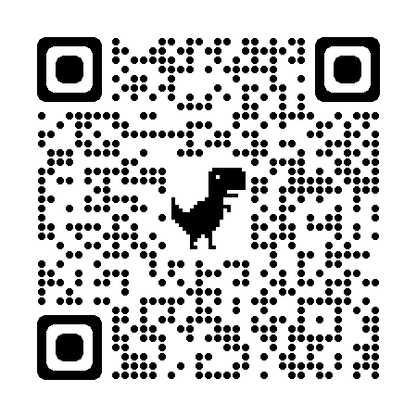
For a full schedule of festivities, event tickets, and all things Conch Republic, visit: ConchRepublic.com.

  

