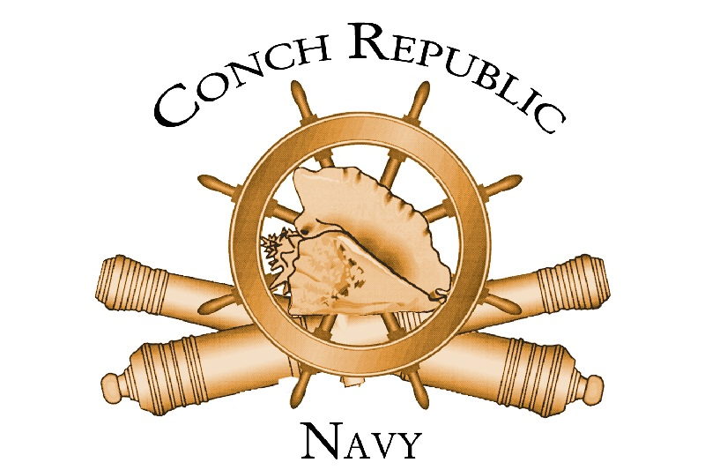

VESSEL COMMISSION
Be it Known, the Good Ship
,
is hereby commissioned as a Privateer in the service of the Conch Republic Navy.

Serving Under the Command of
,
this vessel shall be committed to the defense and protection of the Honor and
Territory of the CONCH REPUBLIC/FLORIDA KEYS against all
enemies, animate or inanimate, and shall proudly represent
our great and tiny nation, wherever she may sail.

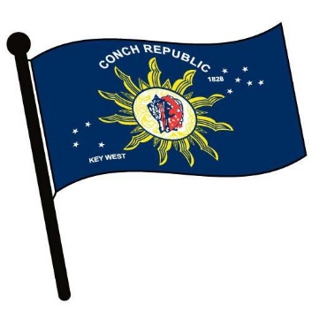
Conch Republic Vessel Commission presented on
This 5th Day of November, in the Year, 2021.
______________________________________________
Admiral Finbar Gittelman, First Sea Lord and Supreme Commander

